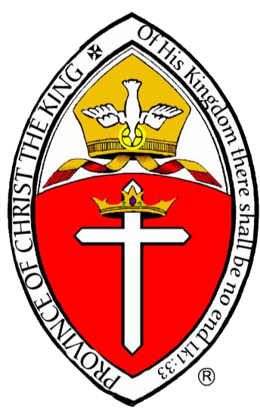
The Anglican Province of Christ the King

All Saints Anglican Pro-Cathedral

Archdiocese of the Atlantic States

131 E. Boughton Road
Bolingbrook, IL60440

(630) 783-8280

August 18, 2023
Feast of St. Helena

Archbishop’s Residence:
517 Goodwin Drive
Bolingbrook, IL 60440
bw.schultz28@gmail.com

Office of the Archbishop

Dear Clergy and Members of the Anglican Province of Christ the King.

In 1973, Richard Nixon resigned as President and Gerald Ford became President. In a speech Ford famously said, “I’m a Ford, not a Lincoln.” I’m here to say, I’m a Schultz, not a Morse. I can’t imagine a person who feels more unworthy and more unqualified to be your Archbishop than I do. So I ask all of you to pray for me. I can’t succeed as Archbishop, if ‘succeed’ is even the right word, without God and your intercessions.
My intention as Archbishop is to continue the vision of our founding Archbishop Robert S. Morse. By this I mean that we continue Our Lord’s command to “. . . Make disciples of all nations, . . . baptizing . . . and teaching them to observe all that I have commanded you.” (Matt. 28:19–20, RSV) But, how do we do that?
James Kushiner, Executive Director of the Fellowship of St. James, and Executive Editor of the magazine Touchstone, asked this rhetorical question “did the Apostles have a plan to evangelize the world on that first Pentecost?” His answer is no. Instead we read in the Acts of the Apostles that “The Spirit fell upon them, making ‘a sound like a mighty rushing wind.’ And there was an explosion of ‘speaking in tongues.’ At this sound . . . a multitude came together and asked the apostles ‘What does this mean?’
“Peter and company suddenly had an audience which they had not planned for, an opportunity to explain the outpouring of the Holy Spirit as the act of ‘this Jesus whom you crucified.’ It was a large crowd, gathered by the Holy Spirit, and 3,000 of them believed and were baptized that day.
“This new fellowship of believers was inspired to devote ‘themselves to the apostles teaching and fellowship, to the breaking of bread and the prayers.’ [And what happened? There was] instant church growth, caught in [the] Apostolic nets, like the miraculous draught of fishes caught by fishermen who could not otherwise catch anything (Luke 5:1–7). [And it was the] Lord’s doing.”
What do we see in “. . . the rest of Acts? [An angel told the Evangelist Philip] to go ‘to the road that goes down from Jerusalem to Gaza.’ He did so, [and] then ‘the Spirit said to Philip, “Go over and join this chariot.”’ After baptizing the Ethiopian eunuch, [Philip] was carried away as the Ethiopian ‘went on his way rejoicing.’ The Gospel seed would be planted in Africa by the Lord’s hand.
“Peter was [confused] on a rooftop in Joppa when three men came to fetch him; they were sent from Caesarea the previous day by Cornelius the Centurion who had been told by an angel to ‘send men to Joppa and bring one Simon who is called Peter.’ This groundbreaking Gentile conversion was not Peter’s initiative but the Lord’s.
“Paul planned his missionary trips, but the Lord was in charge. He recruited Saul on the road to Damascus in the first place. Later, he told the prophets at Antioch, ‘Set apart for me Barnabas and Saul for the work to which I have called them.’ Later, the Holy Spirit blocked Paul’s [journey to Asia,] sending him [instead] to Europe [by way of] a voice in a vision crying, ‘Come over to Macedonia and help us!’ The Lord rerouted him to Europe. What we see here is that the Lord [oversees] Church Growth.
“Sometimes,” Kushiner continues, “some new churches or missions are planted by zealous and motivated Christians, but few if any denominations have arrested their decline this way.” But he concludes “What I am seeing, increasingly, is that people are just showing up at certain churches, coming ‘on their own’ it seems. But if you question them, you will find they have been seeking God and sometimes have stories of dreams or words spoken to them directing them to the church. These churches usually have real faith and a concern for discipleship. They love the Lord.
“The Lord is still sending people into the church, as he sent Saul to [be instructed by Ananias] so long ago. Such teaching can and should be planned [for. But it is the] Lord [who] is sending people to become disciples in churches who welcome and show Christ’s love to visitors, where Christ is truly loved and obeyed.”
So, how do we fulfill Christ’s command? Well, what have I shown you? 1) The fruitful church must love Christ. 2) Success came to the Apostles from the Lord’s initiatives and their obedience to them. 3) God sends us out to labor in His field, but God is in charge. 4) The Lord is sending people to become disciples in churches who welcome and show Christ’s love to visitors, where Christ is truly loved and obeyed.
Please, dear God, let that be said of our Province, our Dioceses, and our Churches.

May God richly bless all of you.

The Most Reverend Blair William Schultz
Archbishop, Anglican Province of Christ the King

